**Carrier Log In**

After Carrier enters his username and password on the Log In page his management account will appear:

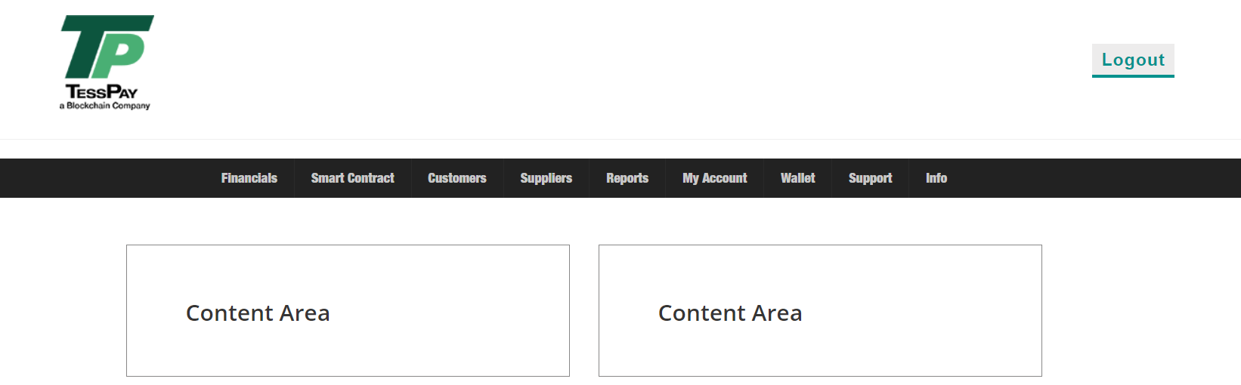

**Financials**

Under financials Carrier will have the following options:

1. Balance
2. Tess Fee Invoices
3. Customer Invoices
4. Supplier Invoices
5. Disputes (this will to be build for final application only)
6. **Balance**

Once the carrier clicks on balance, he will be able to see the current account balance in all currencies (for POC only USD and Tess Coin), he will have the option to withdraw and to top up his wallet balance. Also he will be able to see a statement of account for each currency he owns.

Example:

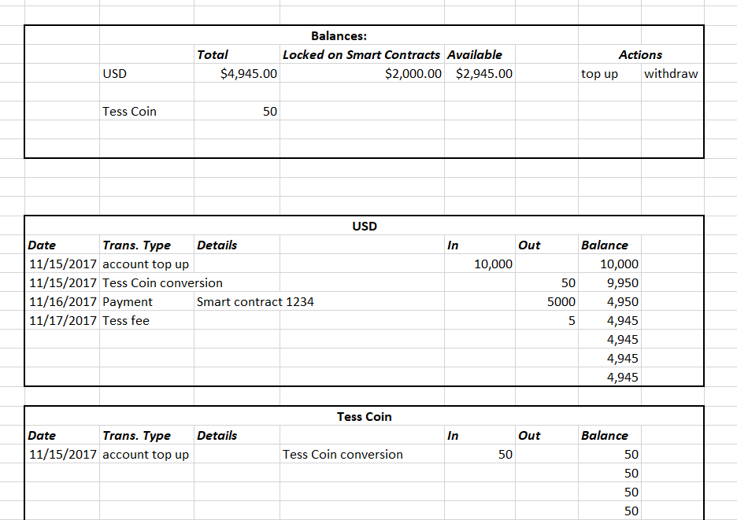

1. **Tess Fee Invoices**

Under this section the carrier will be able to download (I recommend monthly) invoices for the fees charged by Tess on escrow transactions. He will see a list with the invoices and will have a download option. (we may give him a dispute option here too but not for POC, only in the final application)

Example:

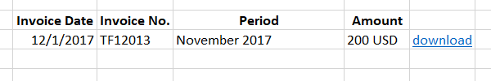

1. **Customer Invoices**

When carrier clicks on this option he will see a list with all the issued invoices, and he will have a “New Invoice” button.

Example:

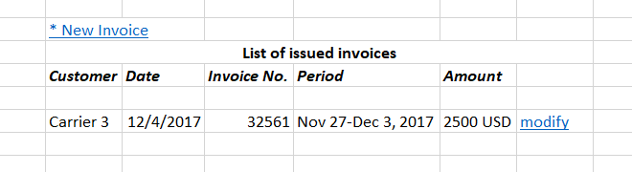

From New Invoice option the carrier will be able to upload invoices for their customers or to create invoices manually. (We may give the semi manual invoice creation possibility from Report section in the final application)

Example:

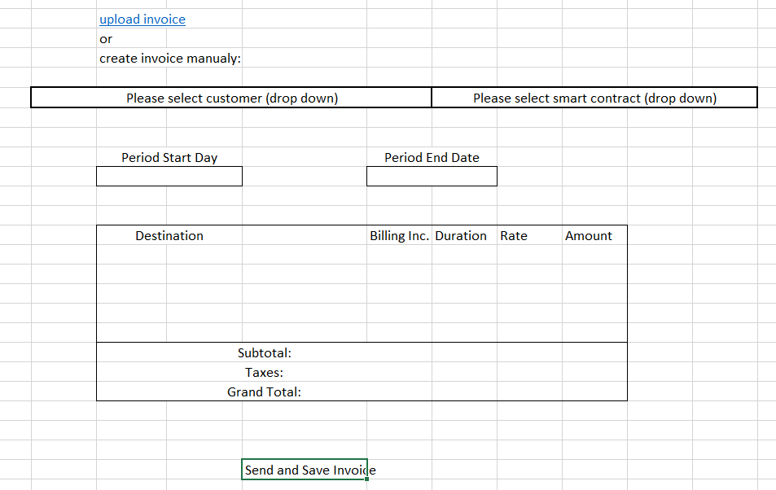

1. Supplier Invoices

Accessing this option Carrier will see invoices issued by suppliers to him. He will have the option to accept or to dispute the invoice. In case Carrier accepts the invoice, Tess will automatically deposit the invoice value into Supplier’s wallet.

Example:

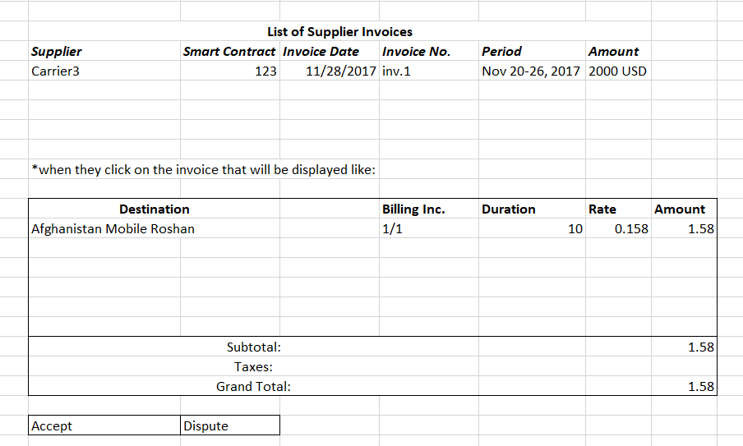

**Smart Contracts**

Under this menu option Carrier will see list with all smart contracts, and he will have the option to “Create New Smart Contract”.

Example:

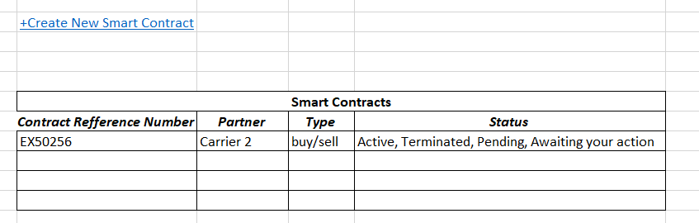

If the Carrier selects “Create New Smart Contract”, he will need to fill the following fields and send the contract to his partner for acceptance.

Example:

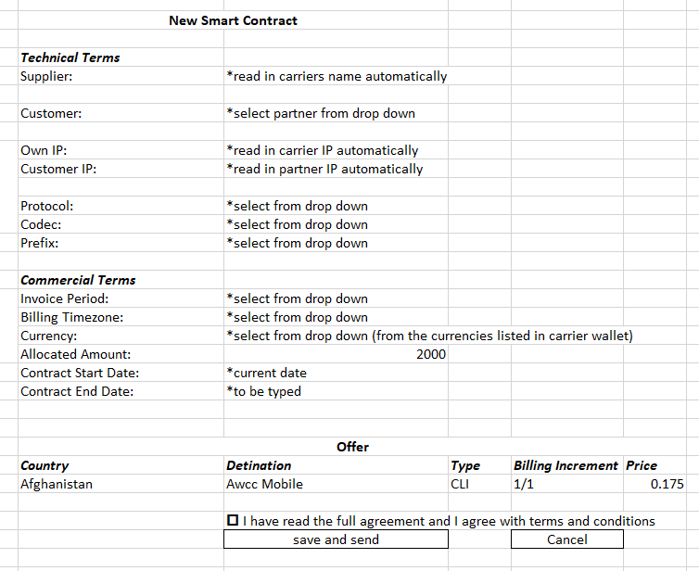

**Customers**

When Carrier selects Customers menu option he will see a list with all his customers. When he clicks on the customer’s name he will see the full customer info provided at registration. And it will give two other tabs (Customer Info, Smart Contracts, Statement of account).

Example:

List of Customers

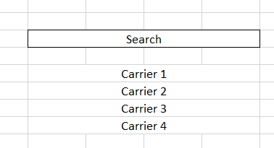

When Carrier clicks on the customer’s name:

